

**Assignment 2**

**Exchanging Data Task**



**GLA1 Data 1**

**Aneta Abazay**

**2022**

Table of Contents

Worksheet 2 Database concepts 3

Task 1 3

3

Worksheet 2 Database concepts 5

Task 2 5

Using MySQL 9

Task 1 9

Creating an EER Diagram 13

Task 1 13

# Worksheet 2 Database concepts

## Task 1

## 

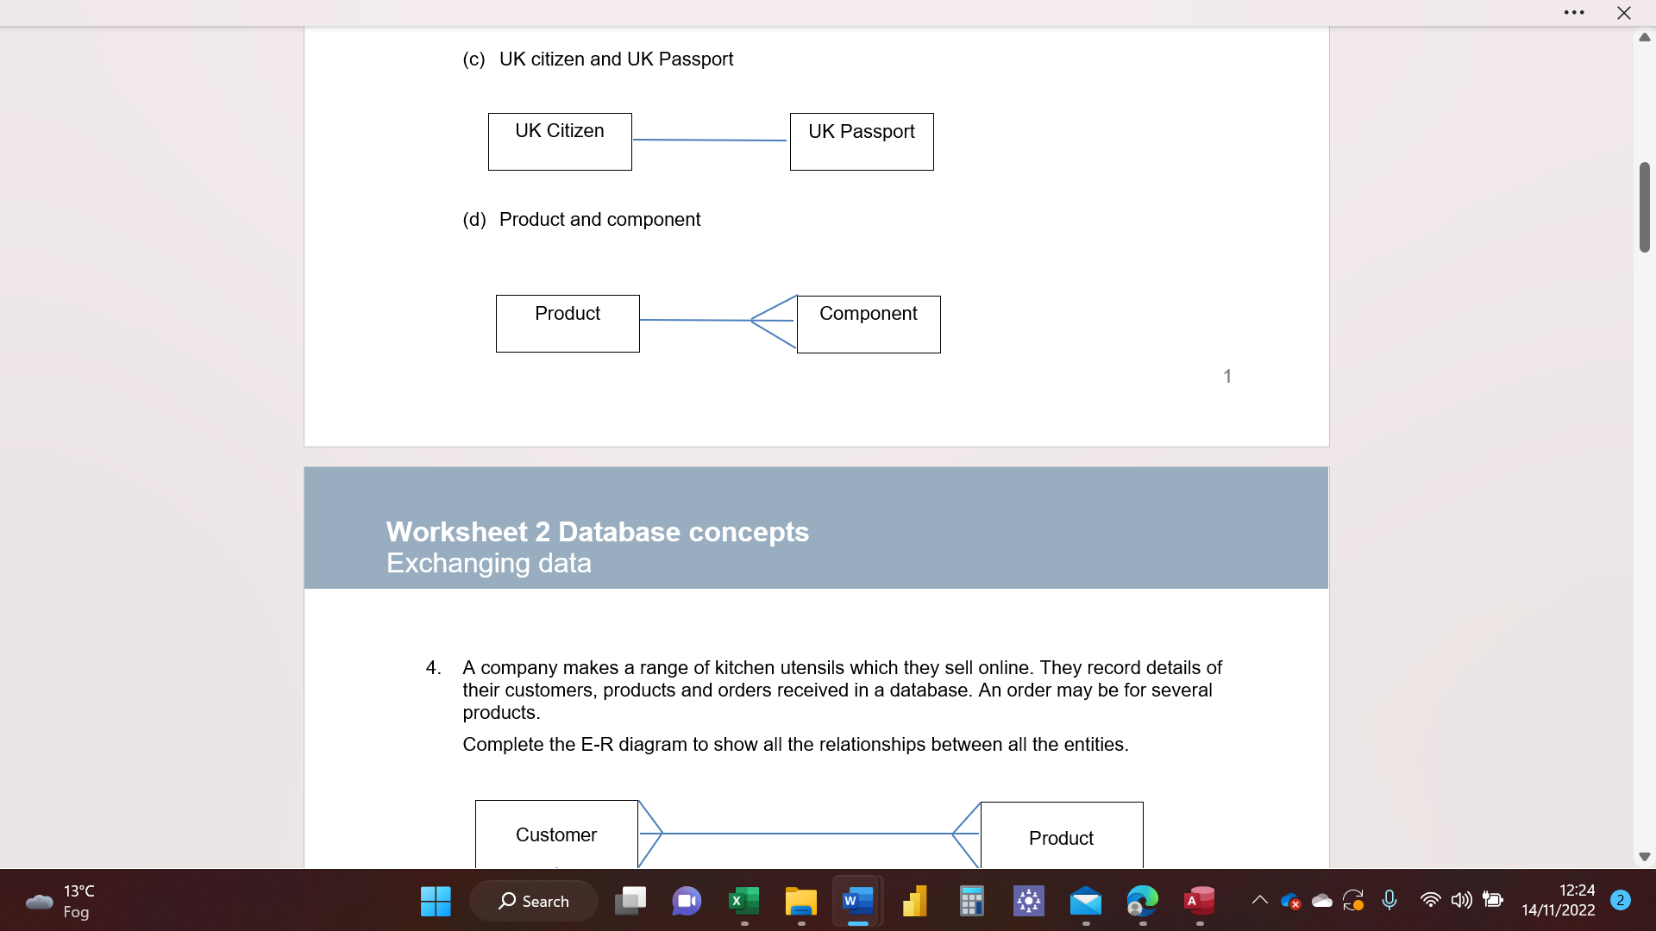

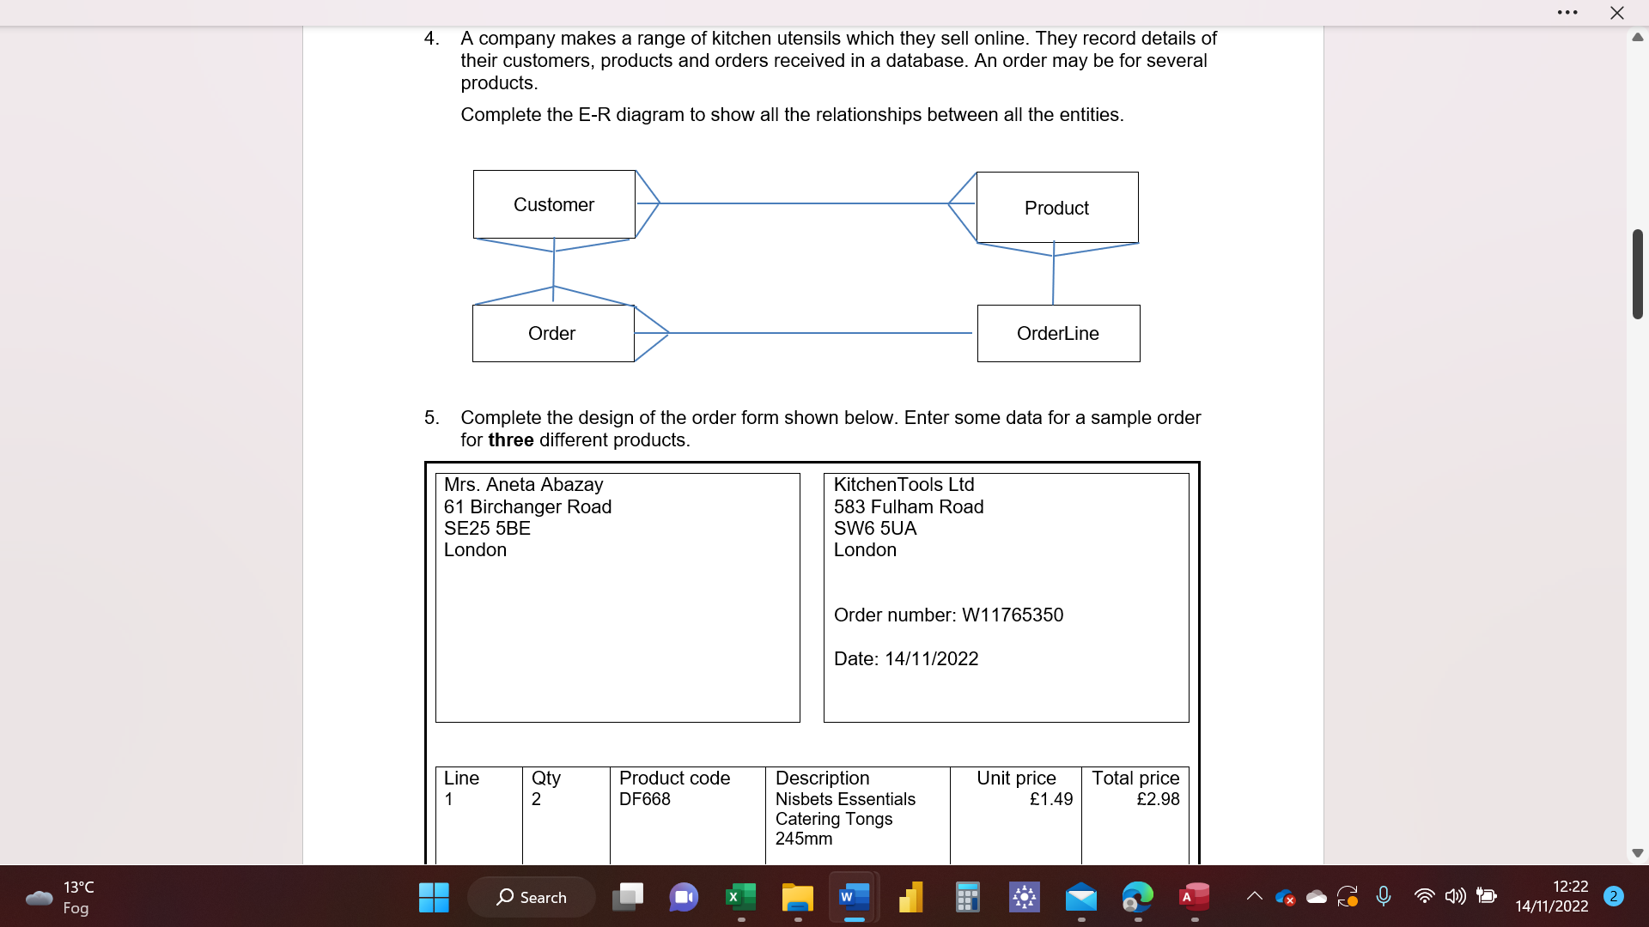

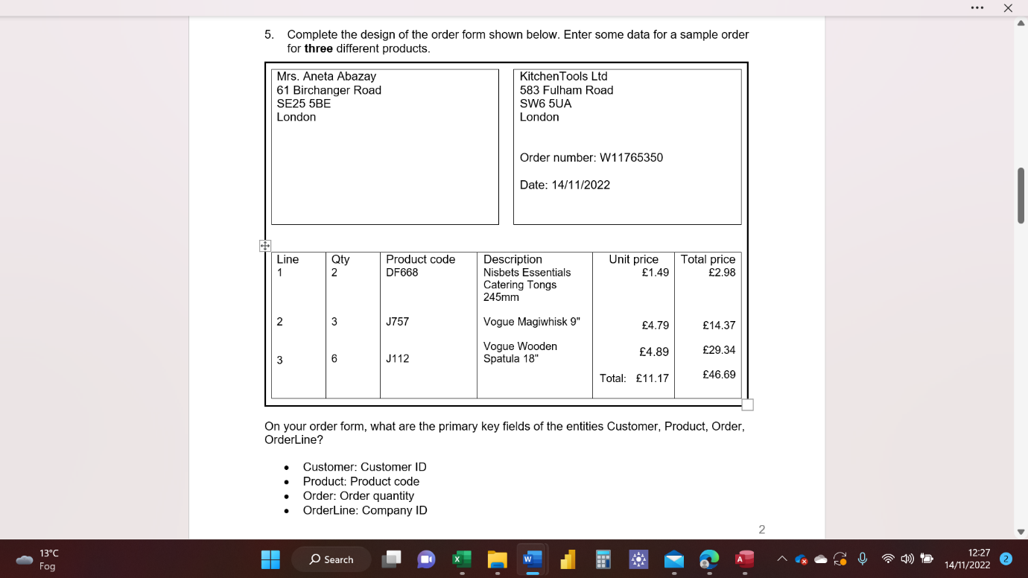

# Worksheet 2 Database concepts

## Task 2

**Step 1**: Add some records to the database

I have entered records provided onto the **tblCustomer** data. See picture below.

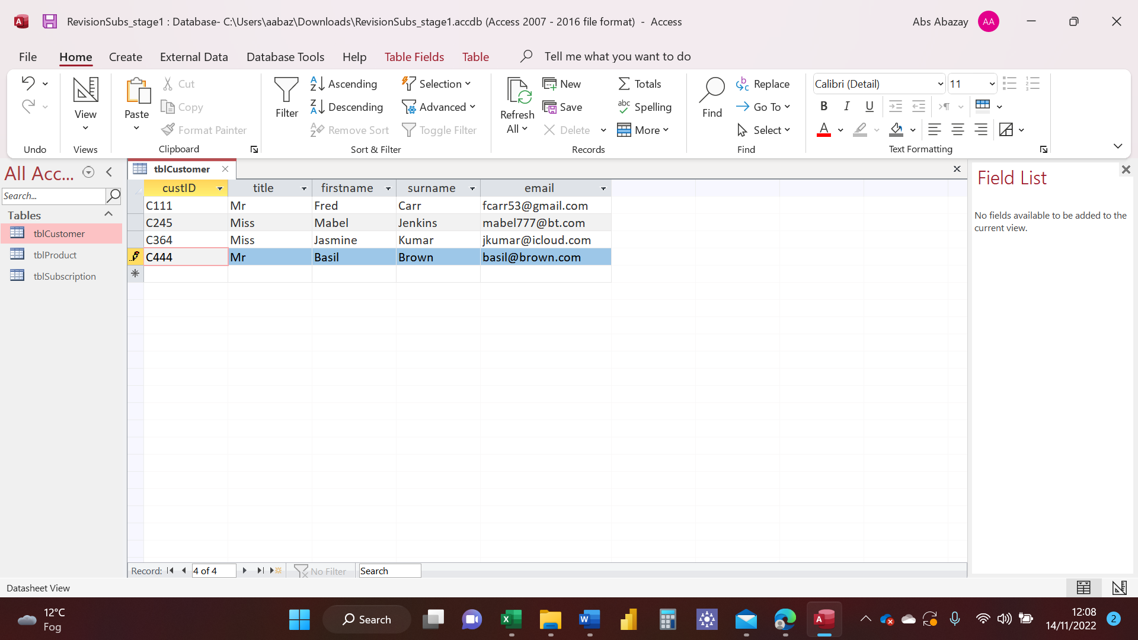

I have then entered records provided onto the **tblSubscription** data. See picture below.

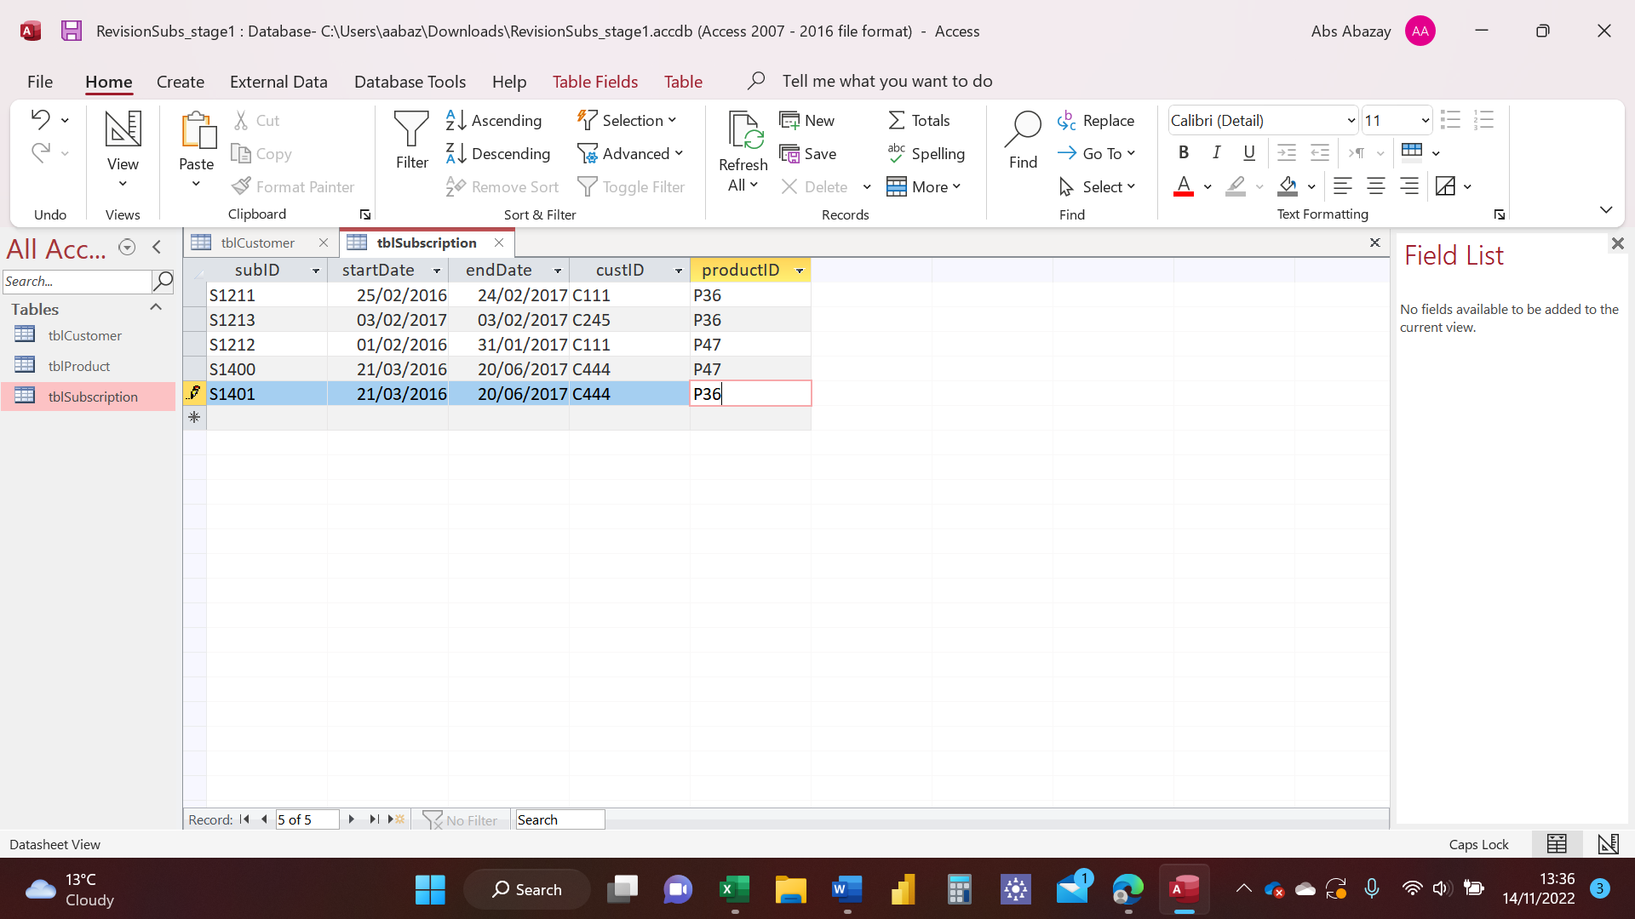

I have then checked the data types to make sure they are correct. I have repeated this on all 3 data sets provided. See picture below.

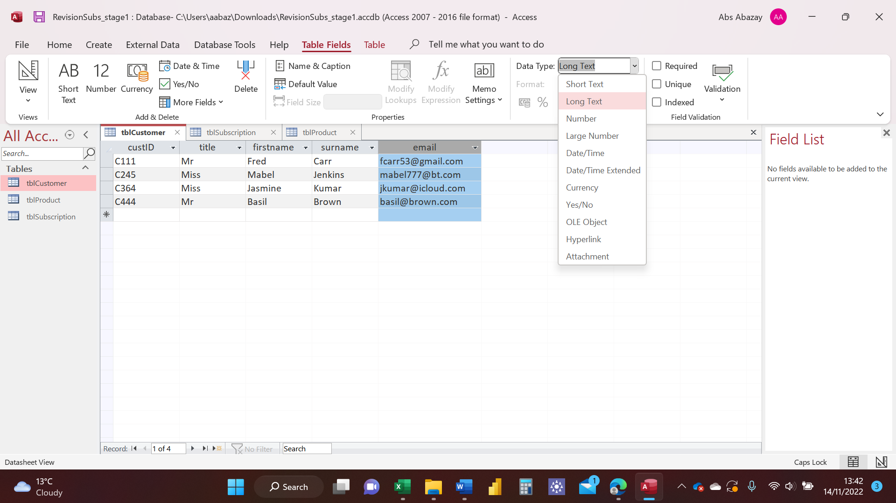

**Step 2**: Designate primary key attribute in each table

I have now created primary key fields for the 3 data sets. I have clicked on View then View Design as show below. 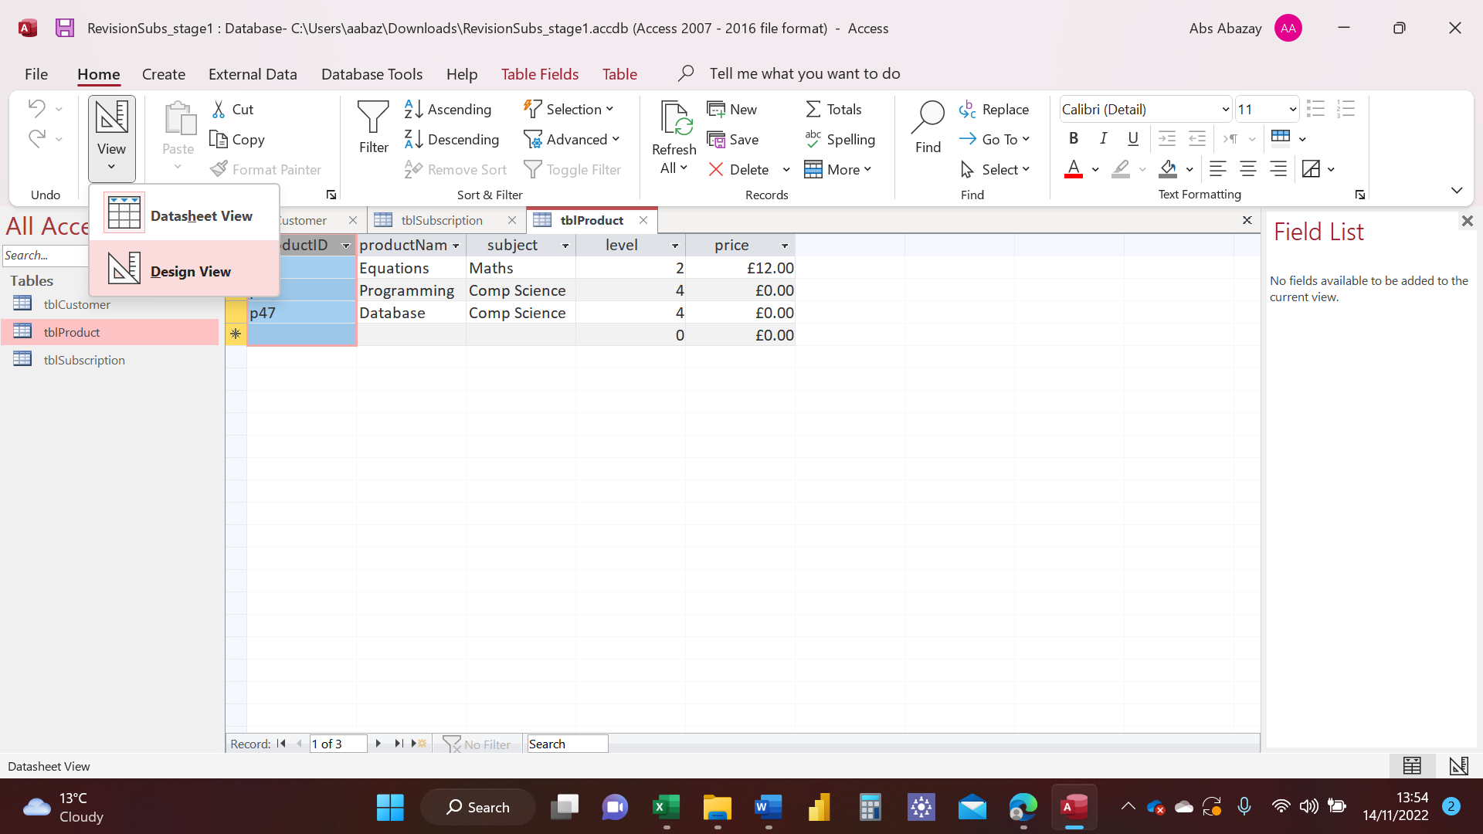

I have then right clicked on the primary field and selected the Primary Key icon to mark those fields.

I have followed the same steps for all 3 data sets. See pictures below. 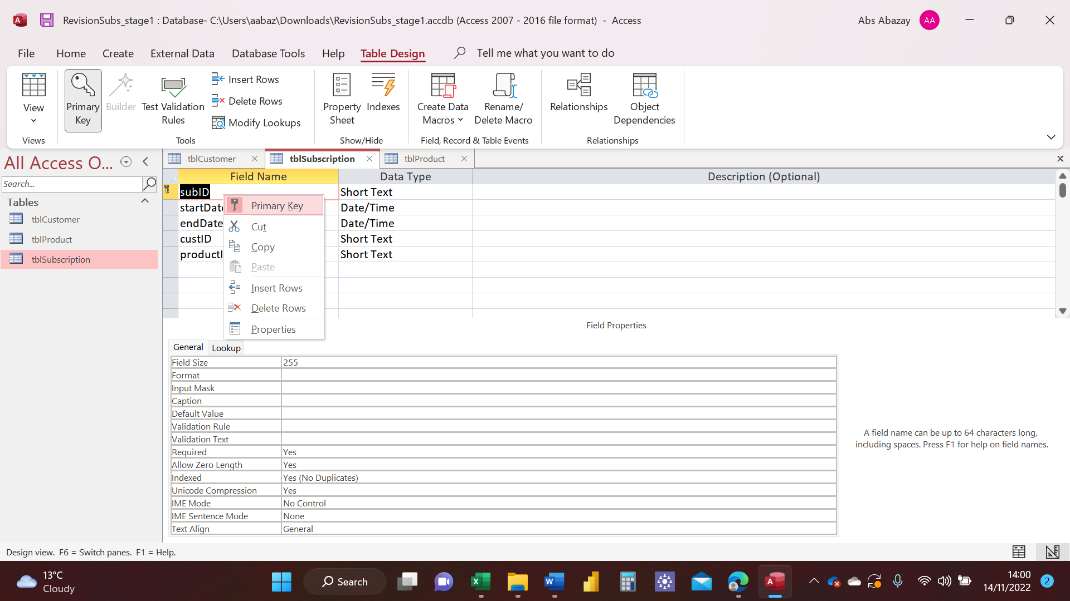

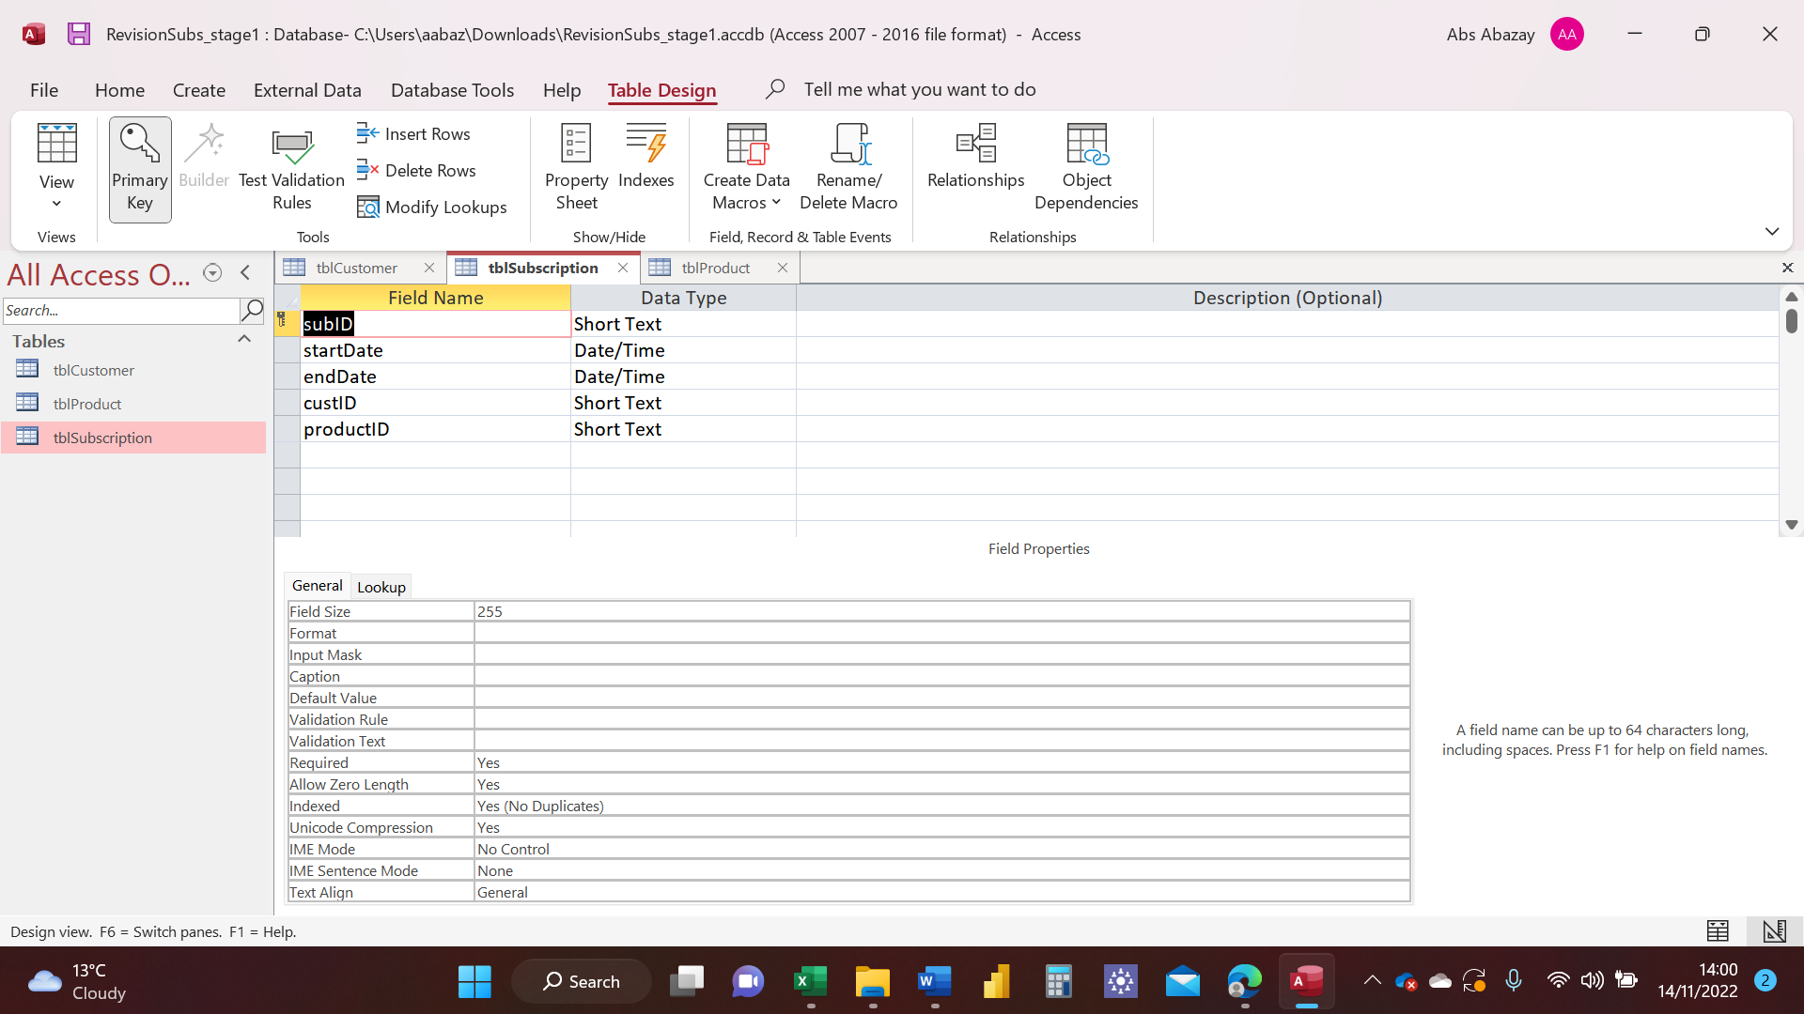

**Step 3**: Creating relationships between the tables.

I have now created relationships between the data sets. I have clicked on **Database Tools** in the main menu. Then double-clicked the **Relationships** icon in the toolbar. See picture below.

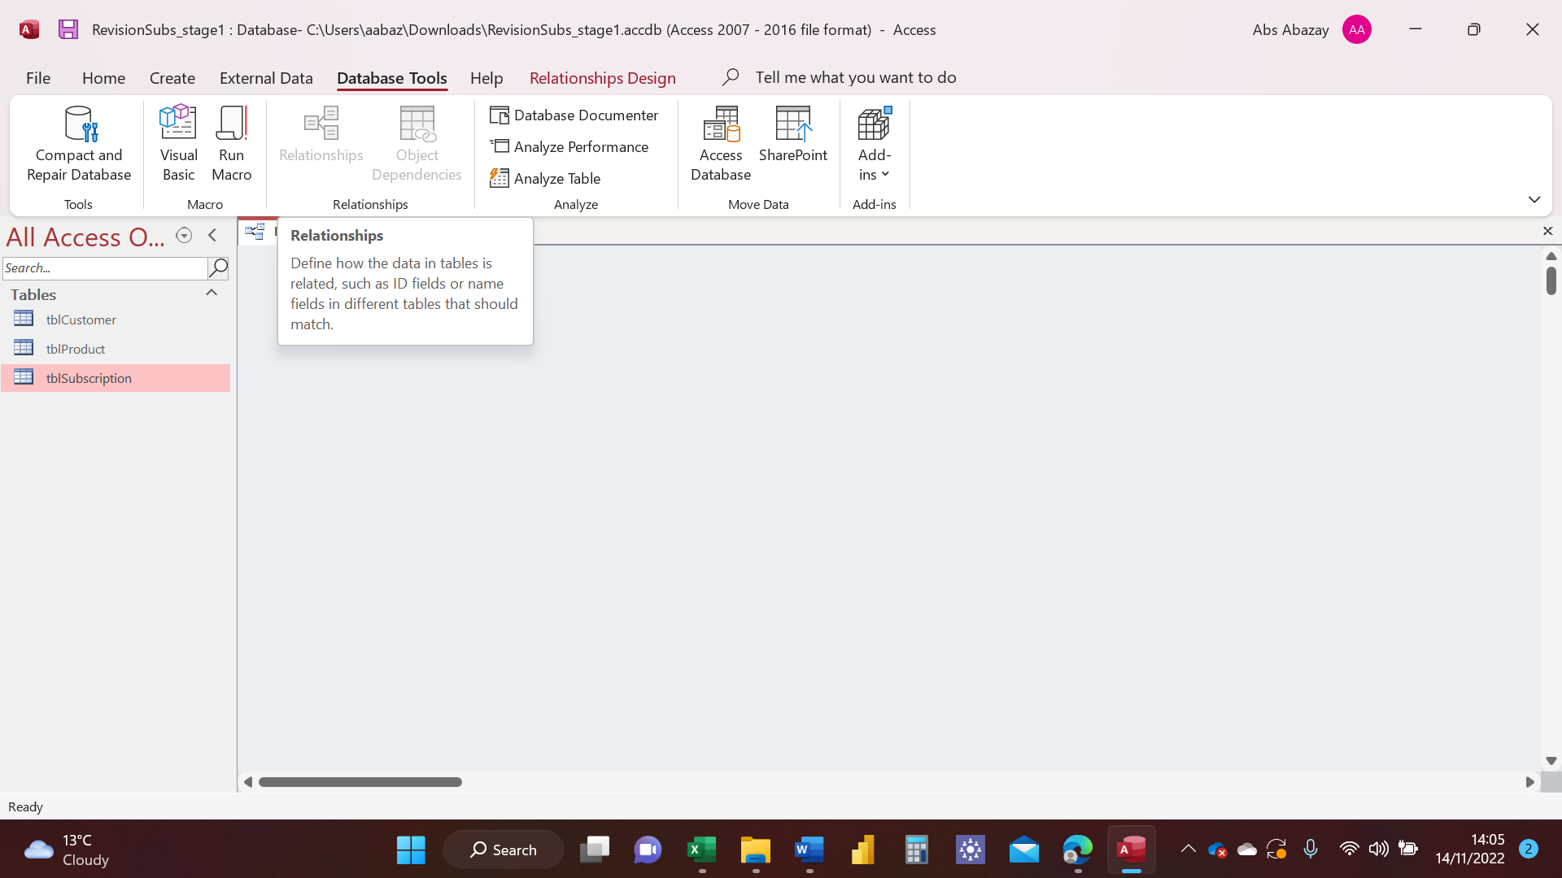

To create a relationship, I have dragged the primary key field from the “one” side to the corresponding field in the “many’’ side of the related table. See picture below.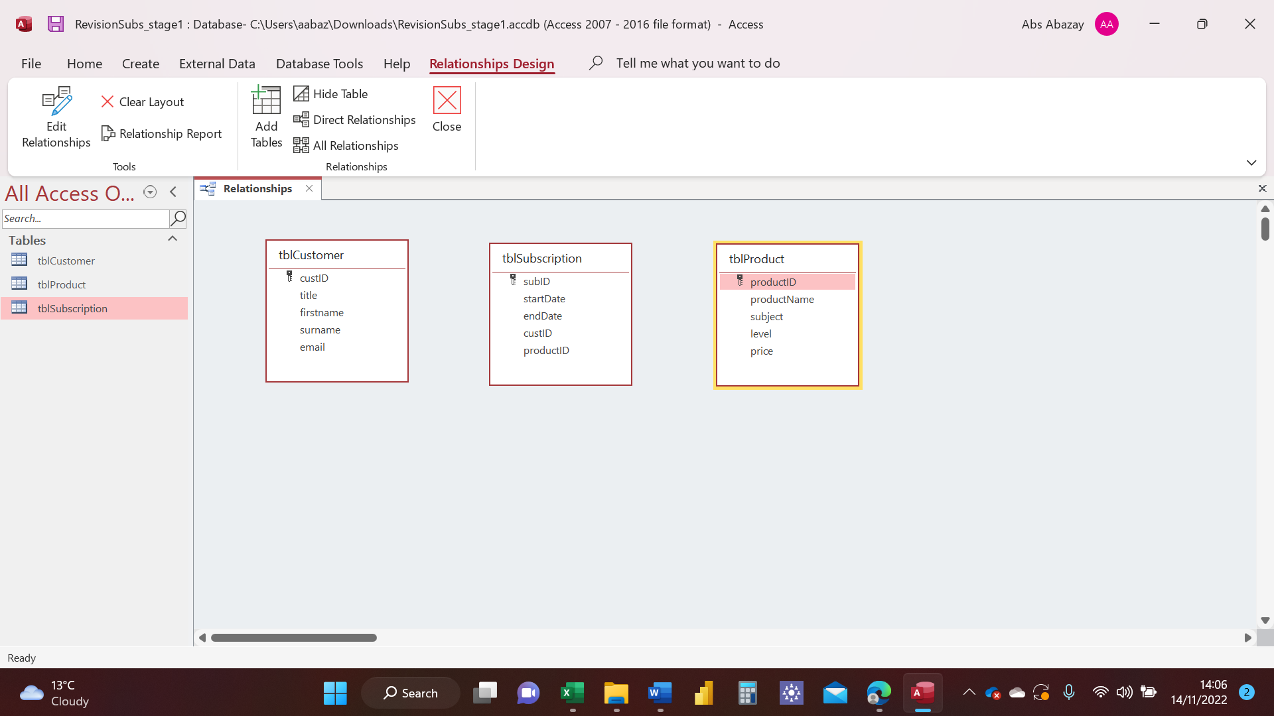

I have dragged **CustID** from **tblCustomer** table to **custID** in **tblSubscription**. See picture below.

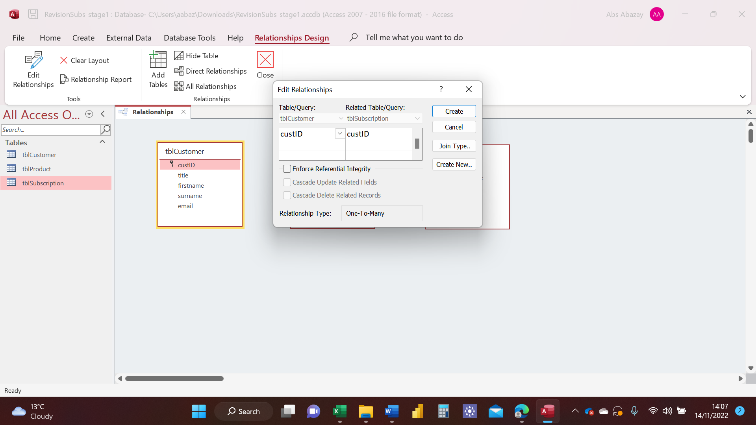

I have then clicked on **Enforce Referential Integrity** to make sure that you cannot create a record in **tblSubscription** for a customer who does not exist in **tblCustomer.**

I have then followed the same step and got my result, see picture below.

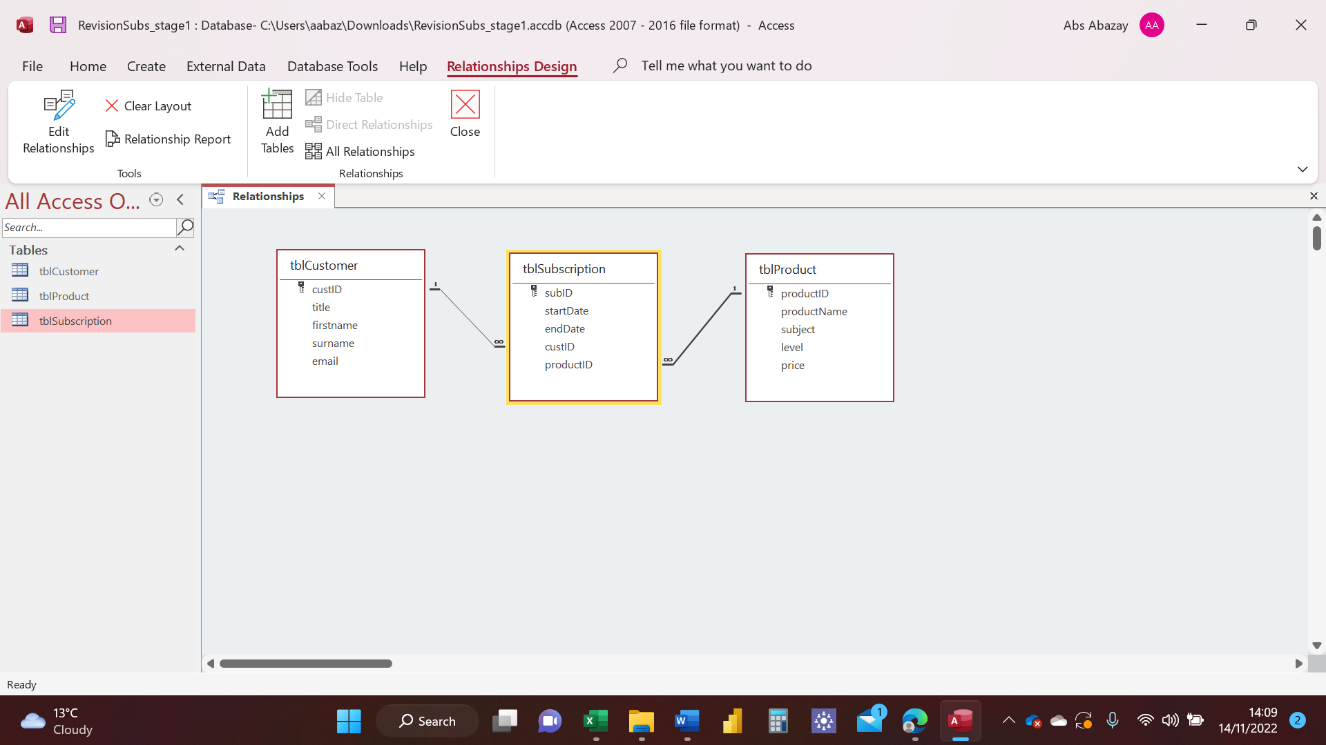

# Using MySQL

## Task 1

I have followed the instructions given to upload data; ‘’create-databases’’ onto MySQL and then I have Run the Queries provided. See pictures below.

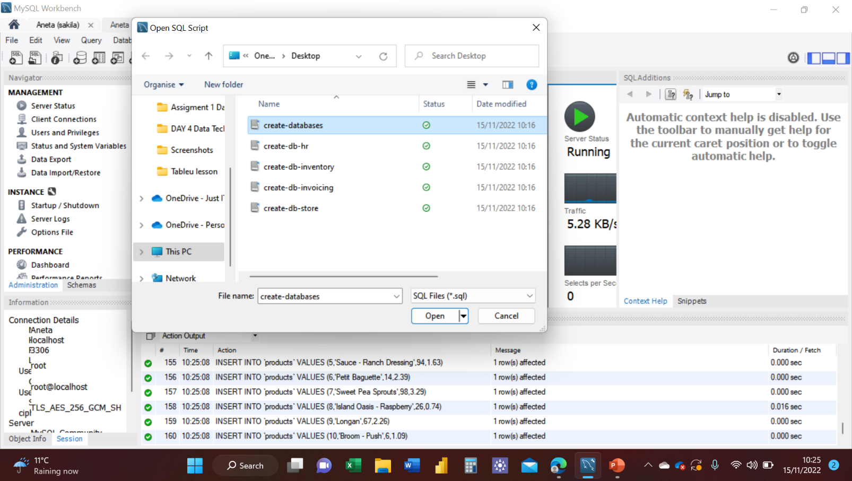

I have typed the Query, to show a list of customers from the **sql_store** data, then used the lightning bolt icon to Run this Query. See picture below.

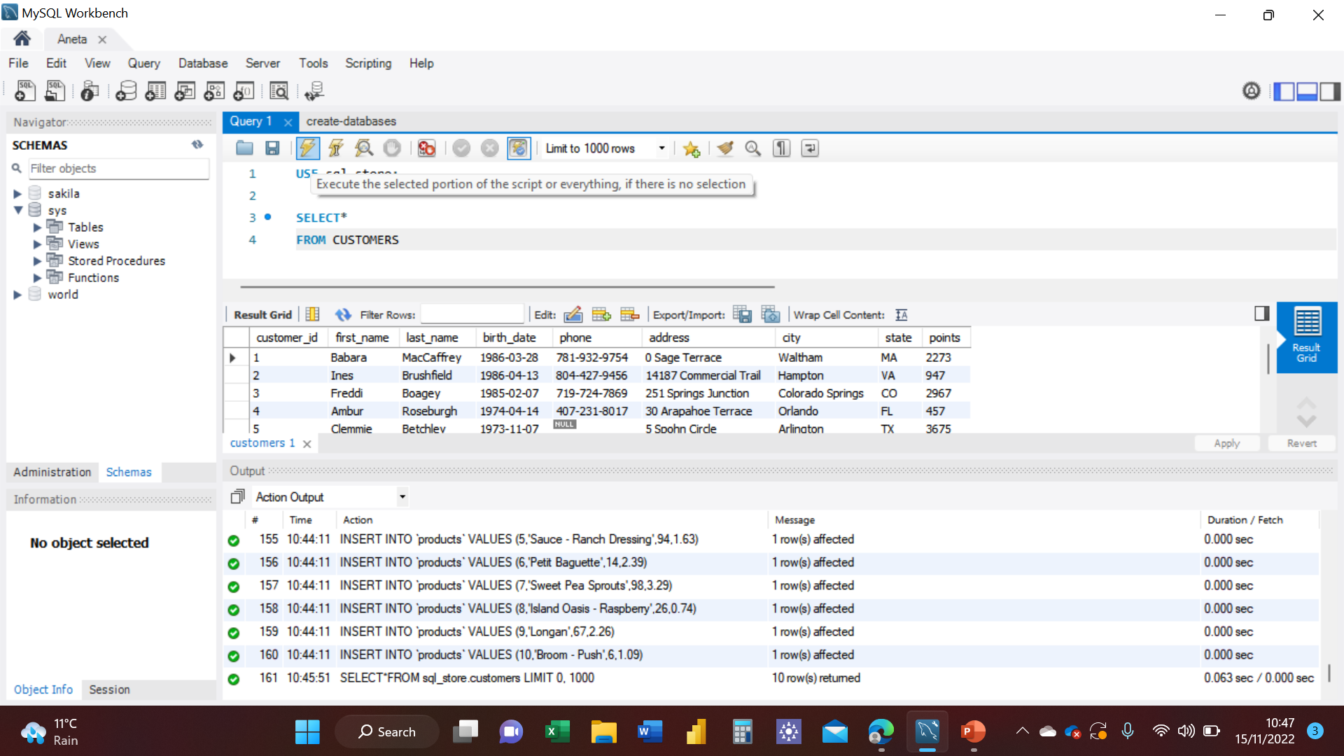

Following the instructions, I have typed another Query, to sort the data by first name, then Run it and those were the results, see picture below.

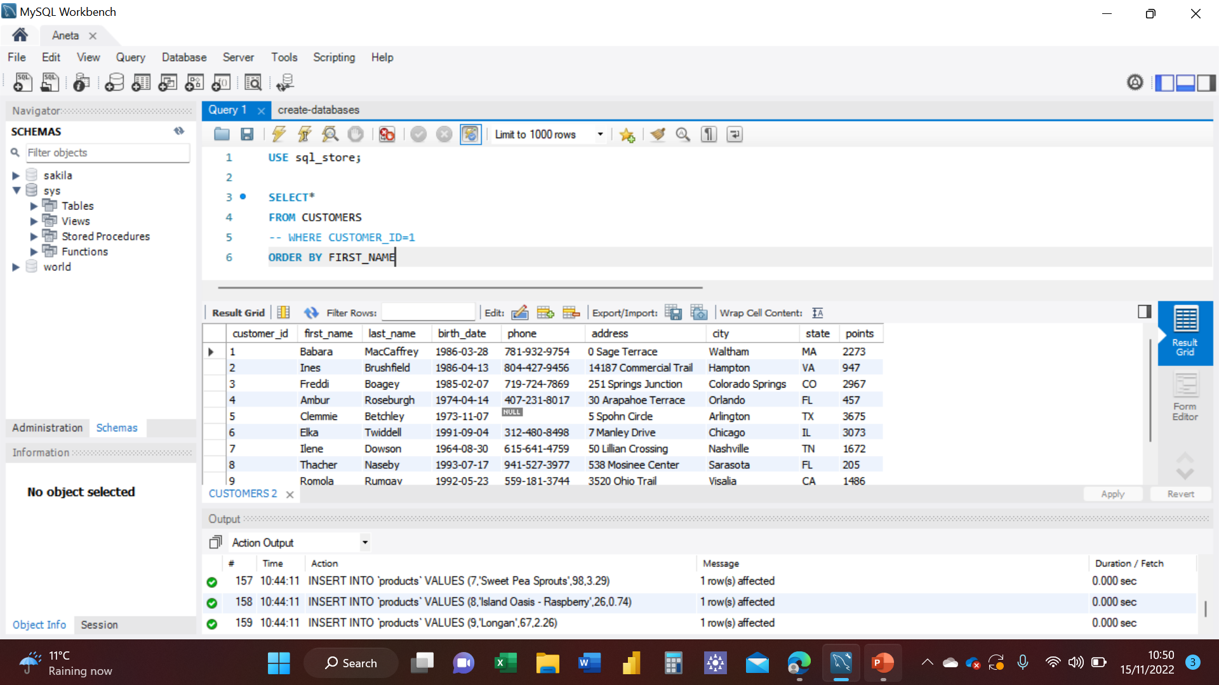

I have then used another Query to sort the data by last name, first name, points and points +10 in that exact order, and those were the results, see picture below.

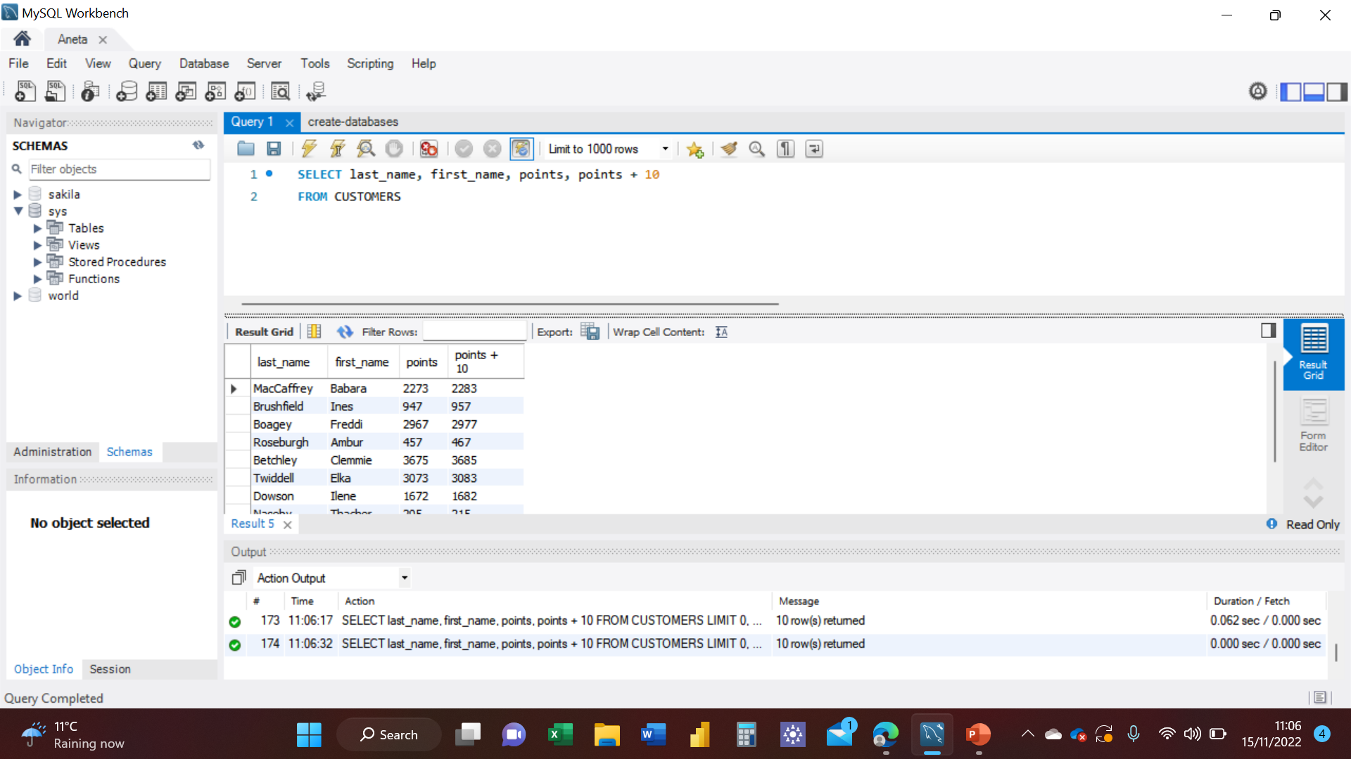

As my first task I have used the Query I’ve created to change the points to times by 10 and plus 100.

I have retyped the Query, but made sure to use all the fields I wanted to be shown on a separate line to make sure I got a clear result. See picture below.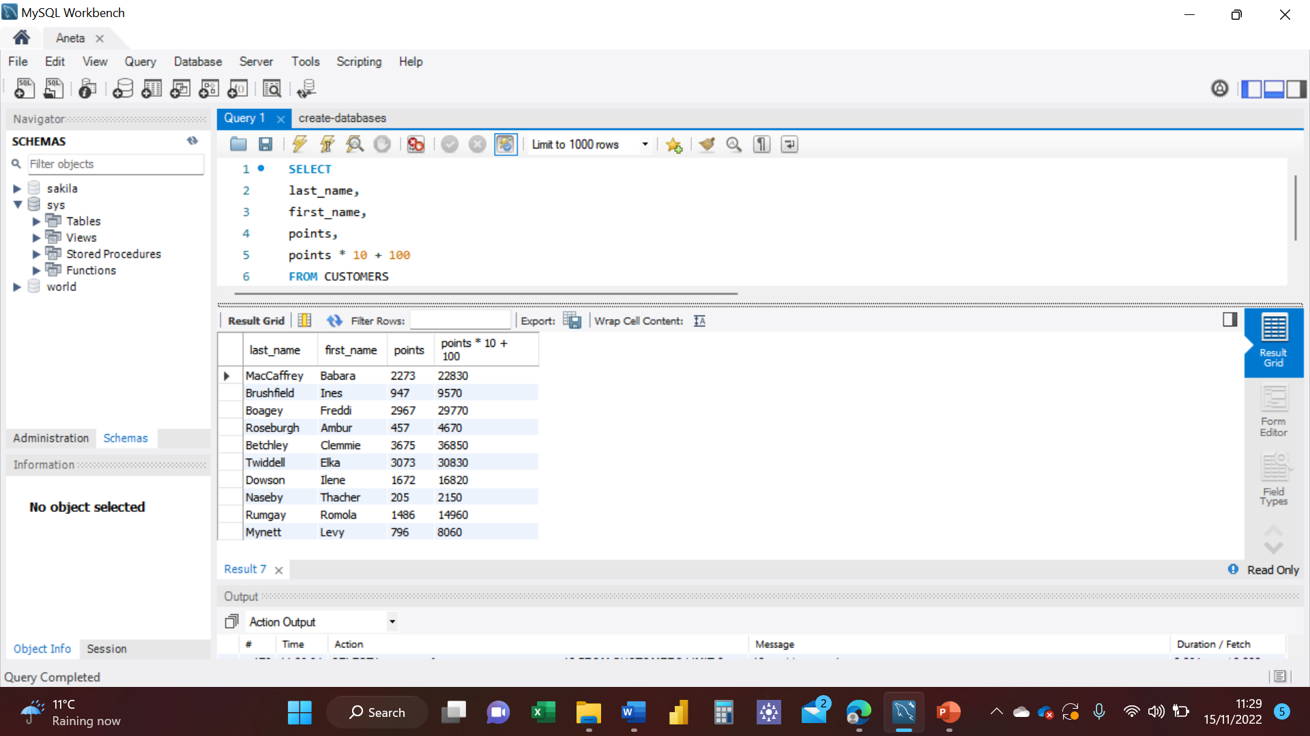

I have now changed the Query code to create a discount factor so the table now shows a discount header and changing the (point + 10) *100. See picture below.

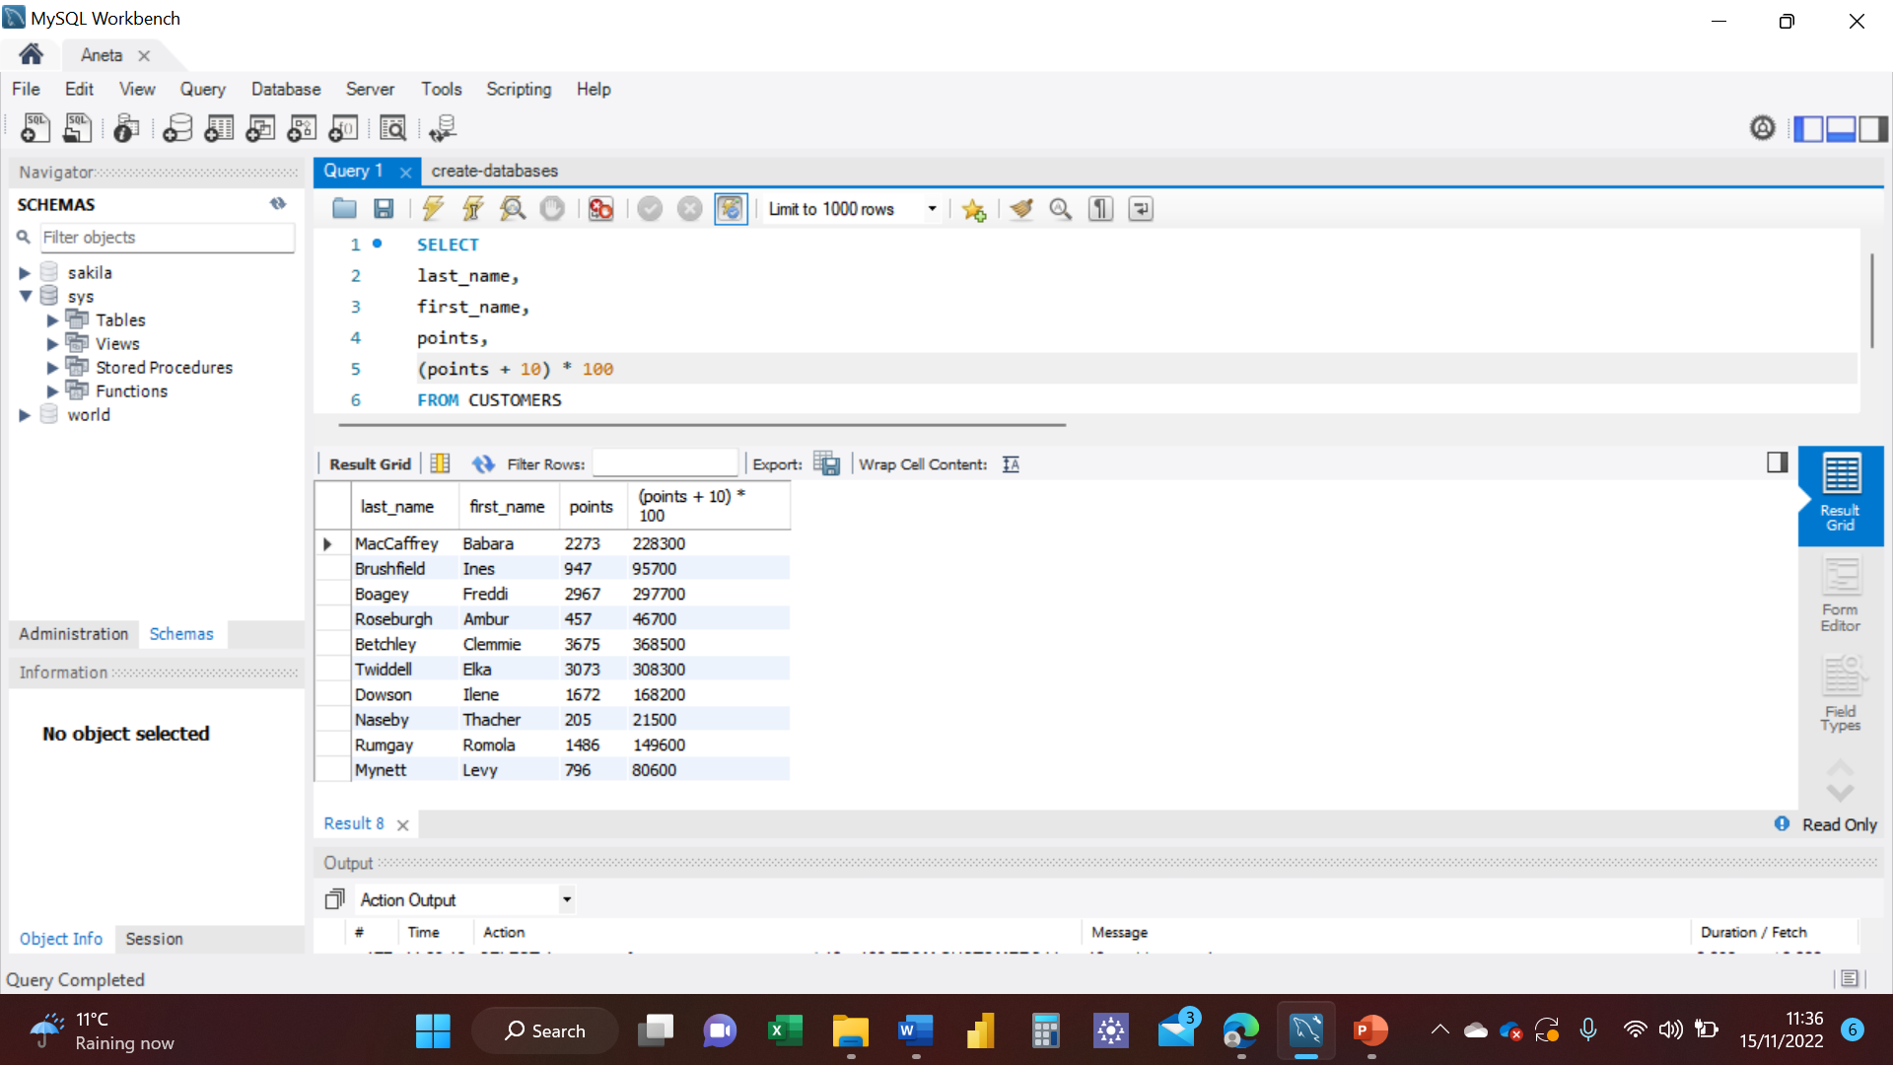

I have now created three new columns; name, unit price and new price which was based on expression (unit price * 1.1). What this expression has done was increased each unit price by 10%.

See pictures below.

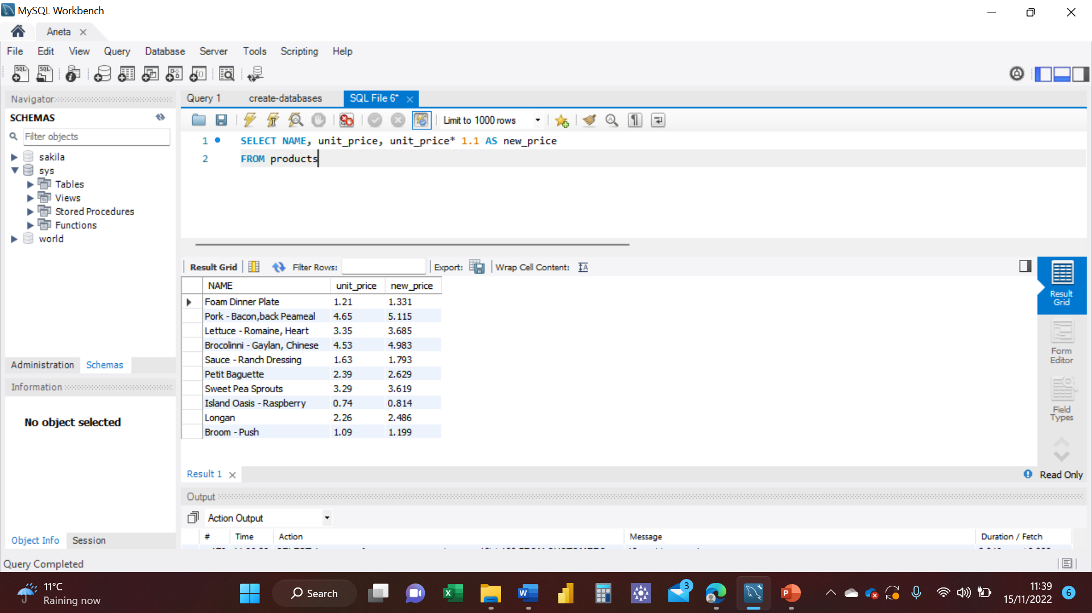

I have now created a new Query that shows all the customers with a date of birth > '1990-01-01'. See picture below.

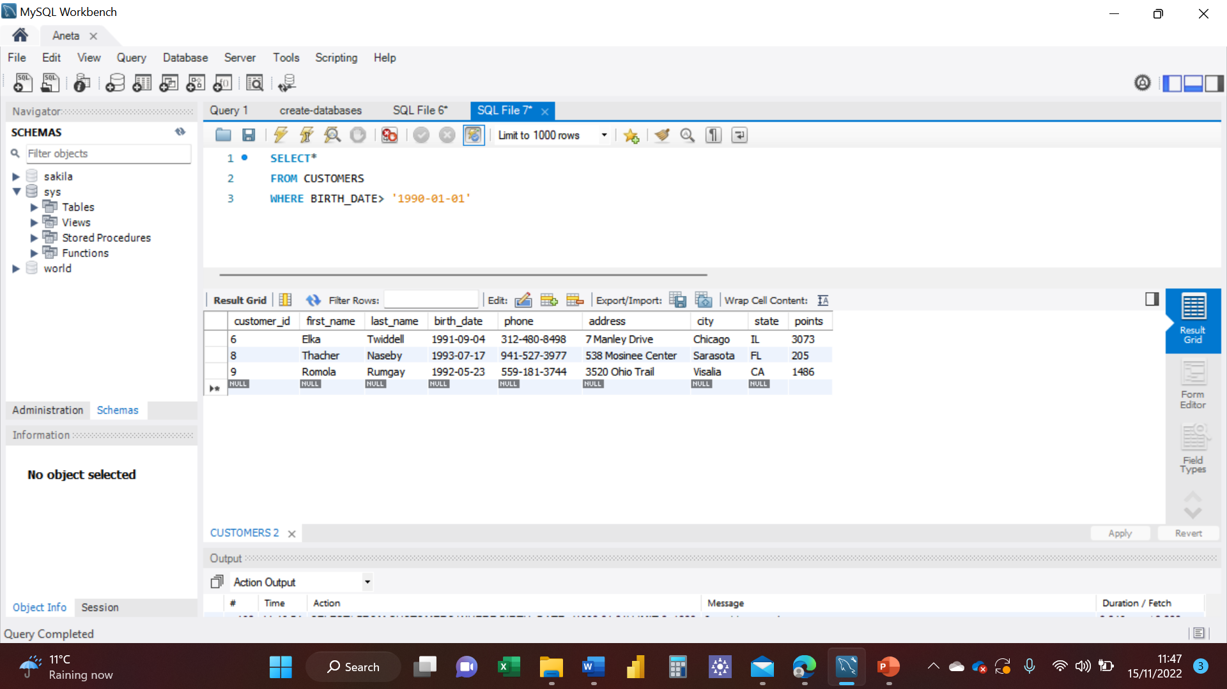

# Creating an EER Diagram

## Task 1

I have now created an EER Diagram by following the steps I will show on the pictures below.

Firstly, I have pressed CRTL + R on my Windows System, then a pop up window was displayed, see picture below.

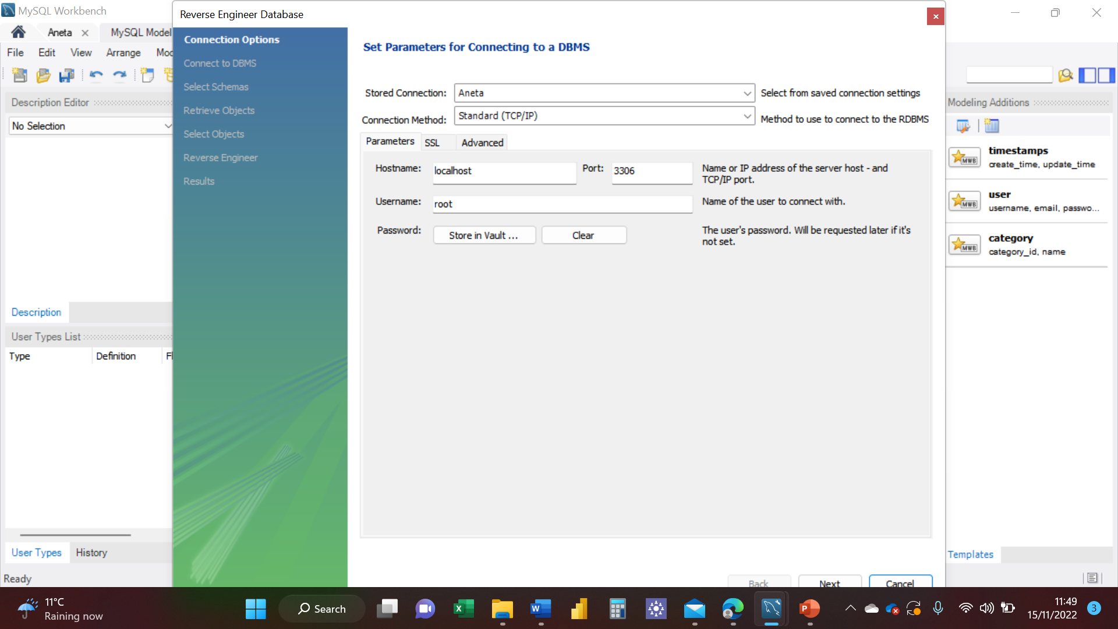

I have then pressed Next, and another window appeared, see picture below.

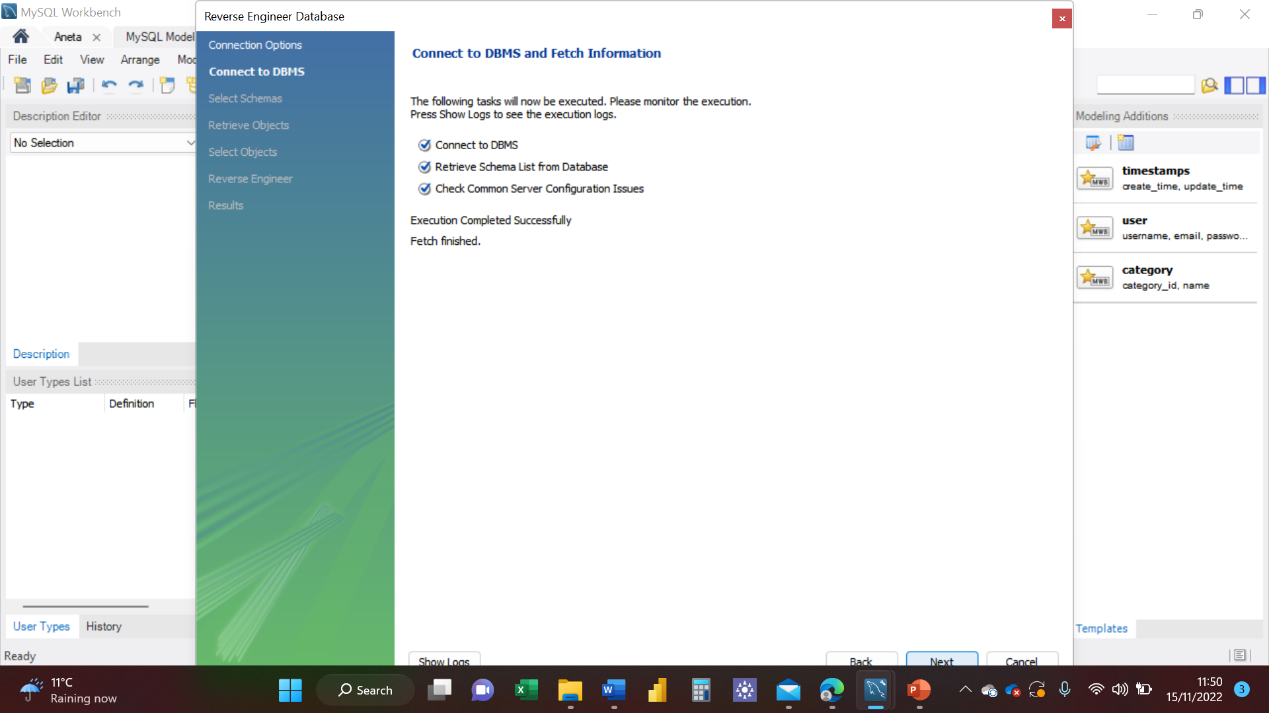

I have pressed Next again, and another window showed, that’s where I have selected **sql_store**, because that’s the dataset I am using, then pressed next again. See picture below.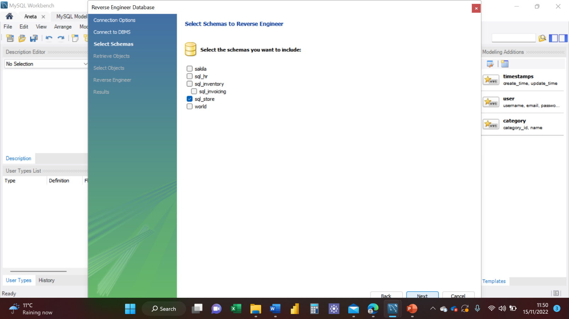

Following the same steps I have continue pressing next till I’ve got the results I wanted. See picture below.

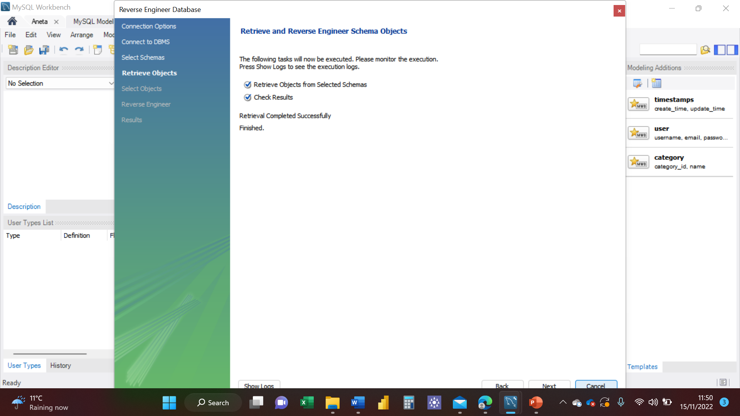

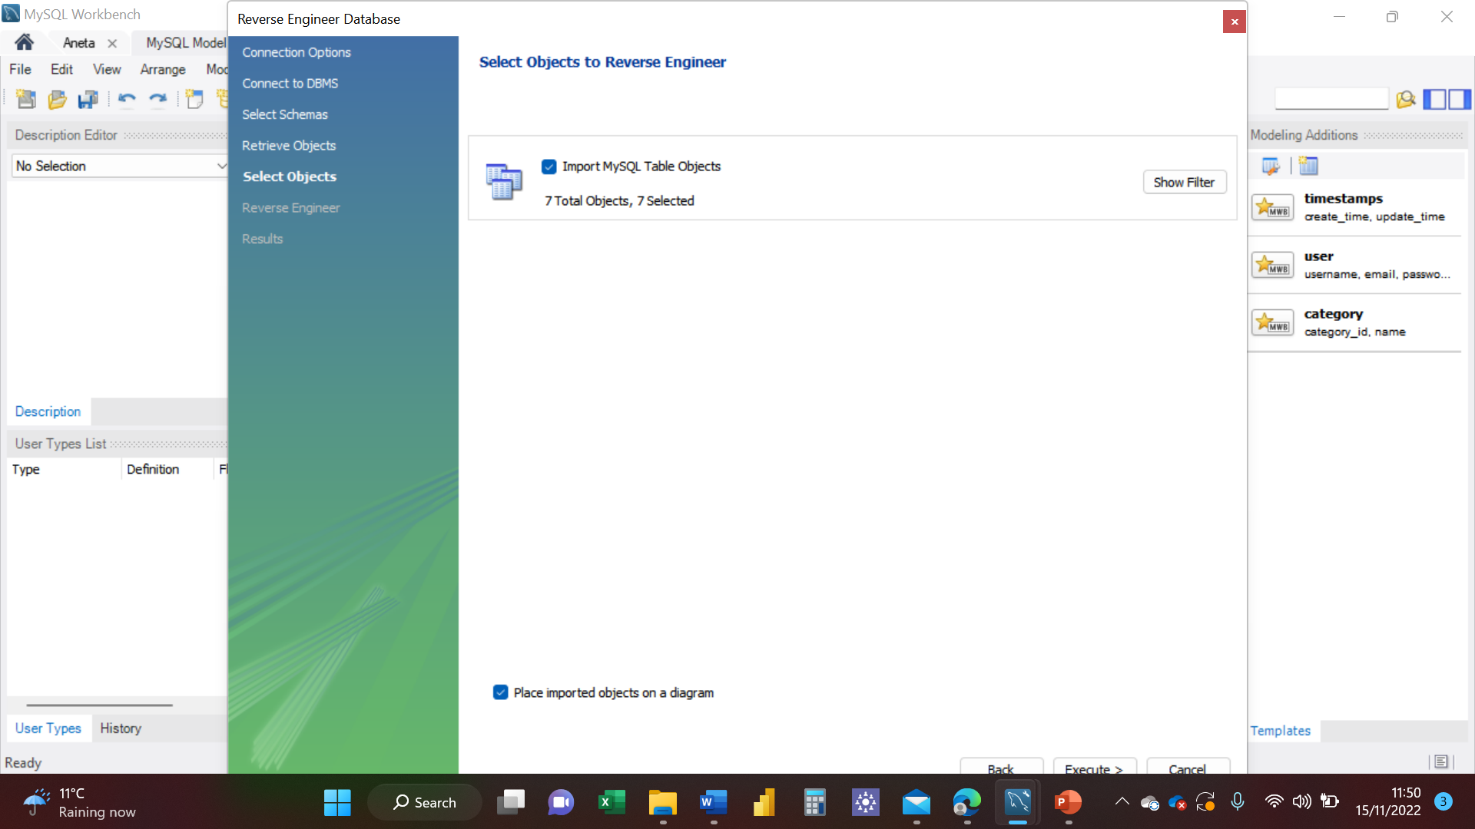

I have now created an EER Diagram. I have moved the fields around to make sure it is easy to read and this is the result, see picture below.

